Annual Water Quality Monitoring – Jan 2022 to Feb 2023
Marokopa Catchment Care
Samples were collected monthly (between Jan-22 and Feb-23) at Marokopa River and Tawarau River by Waikato Regional Council and quarterly at all other sites (on 11th May-22, 14th Aug-22, 16th Dec-22 & 9th Feb-23) by KCRC. Quarterly samples are grouped by season, whereby May = Autumn, Aug = Winter, Dec = Spring, and Feb = Summer.
Results indicated that E. coli and sediment are the main contaminates to be aware of. E. coli concentrations were lower in winter and higher in autumn. Suspended sediment (measured as water clarity) was lower in autumn and higher in winter. Concentrations of nitrate and ammonia were low. Concentrations of dissolved reactive phosphorus were slightly elevated at 50% of sites.
- E. coli was elevated at all sites with the lowest concentrations were measured at 41-Puaroa Stream (361, 95th percentile value) and the highest concentrations recorded at Tawarau River (1,550). All sites had concentrations below the sub-catchment (SC) baseline (5yr baseline = 1,870). Overall, concentrations were lower in winter and higher in autumn.
- Nitrate concentrations were well below toxicity levels at all sites. Median concentrations were lowest at 42-Kiritehere Stream (median 0.05 mg/L; 95th percentile ≤ 0.07 mg/L) and highest at 40-Wairoa Str (median 0.38 mg/L; 95th percentile ≤ 0.58 mg/L). Two out of six sites had median nitrate concentrations above the SC baseline and four sites had 95th percentile levels above the baseline (5yr baseline = median 0.30 mg/L; 95th percentile ≤ 0.43 mg/L). In general, concentrations were higher in winter and lower in spring.
- Ammonia concentrations were exceptionally low at 5 out of 6 sites (median & 95th percentile < 0.01) and slightly higher at 40-Wairoa Stream (median ≤ 0.019mg/L; 95th percentile ≤ 0.039 mg/L). 40-Wairoa Stream was the only site to have ammonia concentrations above the SC baseline (5yr baseline = median < 0.01 mg/L; 95th percentile 0.019 mg/L).
- The combined concentration of Nitrate and Ammonia exceeded 0.5 mg/L at two sites (39-Mangaohuinga Stream and 40-Wairoa Stream) during the time of winter sampling only (14 August). Ecological impacts, including problematic growth of algae and/or aquatic plants and loss of sensitive aquatic species are likely when the combined concentration of nitrate and ammonia regularly exceed 0.5 mg/L.
- Dissolved reactive phosphorus (DRP) concentrations were low at 3 out of 6 sites (median ≤ 0.009 mg/L; 95th percentile ≤ 0.011 mg/L) and slightly elevated at the other 3 sites (median ≥ 0.012 mg/L; 95th percentile ≥ 0.013 mg/L). Tawarau River was the only site to have median DRP concentrations equal to the SC baseline. All sites were below the 95th percentile baseline (5yr SC baseline = median 0.013 mg/L; 95th percentile ≤ 0.022 mg/L). In general, concentrations were slightly higher in autumn.
- Water clarity was poor at 5 out of 6 sites (≤ 1.28 m), relative to the national bottom line (NBL) (either 0.61 m or 1.34 m). Water clarity was good at Tawarau River (0.97 m) which was the only site to have a NBL of 0.61 m, while the NBL for all other sites is 1.34 m. Five out of six sites had water clarity values below the SC baseline (5yr SC baseline 1.21 m). Water clarity was lowest in winter, corresponding to higher river flows. This indicates higher suspended sediment loads during winter/high flow periods.

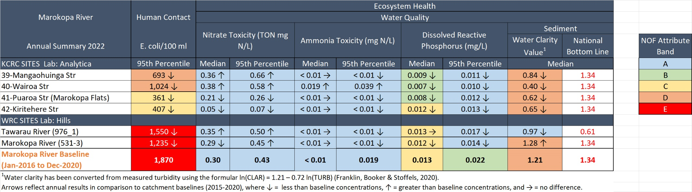
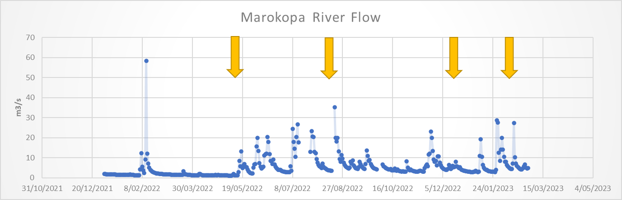
Yellow arrows in the rainfall and river flow graphs show the dates when quarterly water samples were collected.

