Annual Water Quality Monitoring – Jan 2022 to Feb 2023
West Coast Sub-catchments
Samples were collected monthly (between Jan-22 and Feb-23) at Oparau River by Waikato Regional Council and quarterly at all other sites (on 11th May-22, 14th Aug-22, 16th Dec-22 & 9th Feb-23) by KCRC. Quarterly samples are grouped by season, whereby May = Autumn, Aug = Winter, Dec = Spring, and Feb = Summer.
North Kawhia Harbour Care
Freshwater quality was fairly good. The main contaminates to be aware of are E. coli and sediment. Concentrations of E. coli were generally higher in spring and lower in winter. The concentration of suspended sediment (determined by water clarity) was higher in winter (2022) and summer (2023), corresponding to the periods of highest rainfall.
- E. coli concentrations were lowest at 31-Oparau River and 32-Mangapapa Stream (210 and 231, 95th percentile values). E. coli was elevated at all other sites with the highest concentrations at 33-Te Kauri Stream (710). All sites were below the sub-catchment (SC) 5yr baseline (2016-2020 baseline = 2,545). Concentrations were generally higher in spring and lower in winter.
- Nitrate concentrations were below toxicity levels at all sites and were very low at 4 out of 5 sites (median ≤ 0.39 mg/L; 95th percentile ≤ 0.50 mg/L). Concentrations were lowest at 31-Oparau River (median 0.12 mg/L; 95th percentile ≤ 0.24 mg/L) and highest at 32-Mangapapa Stream (median 0.62 mg/L; 95th percentile 0.73 mg/L). All sites had annual nitrate concentrations above the SC baseline (5yr baseline = median 0.10 mg/L; 95th percentile ≤ 0.38 mg/L). Concentrations were generally highest in winter and lowest in spring.
- Ammonia concentrations were exceptionally low at all sites (median < 0.01 mg/L; 95th percentile ≤ 0.022 mg/L). Oparau River (658_1) was the only site to have a 95th percentile above the SC baseline (5yr baseline = 95th percentile ≤ 0.017 mg/L).
- The combined concentration of Nitrate and Ammonia exceeded 0.5 mg/L at 32-Mangapapa Stream. Ecological impacts, including problematic growth of algae and/or aquatic plants and loss of sensitive aquatic species can occur when the combined concentration of nitrate and ammonia regularly exceeds 0.5 mg/L.
- Dissolved reactive phosphorus (DRP) concentrations were low at 4 out of 5 sites (median ≤ 0.009 mg/L; 95th percentile ≤ 0.018 mg/L). Concentrations were slightly elevated at 34-Awaroa River (median 0.015 mg/L; 95th percentile ≤ 0.019 mg/L). Only one site (32-Mangapapa Stream) had median and 95th percentile DRP concentrations below the SC baseline. All other sites were above the baseline (5yr SC baseline = median 0.006 mg/L; 95th percentile ≤ 0.010 mg/L). Concentrations were generally higher in autumn and lower in spring and summer.
- Water clarity was good at Oparau River-658_1 and 31-Oparau River (median values 2.23 m and 1.68 m) and poor at all other sites (≤ 1.53 m), relative to the national bottom line (1.34 m). The highest water clarity was recorded at Oparau River-658_1 (2.23 m). The lowest was recorded at 33-Te Kauri Stream (1.0 m). Two sites (34-Awaroa River and 33-Te Kauri Stream) had median water clarity values below the SC baseline (5yr SC baseline = median 1.45 m). Water clarity was lower in summer and winter and higher in autumn corresponding to the periods of highest rainfall.
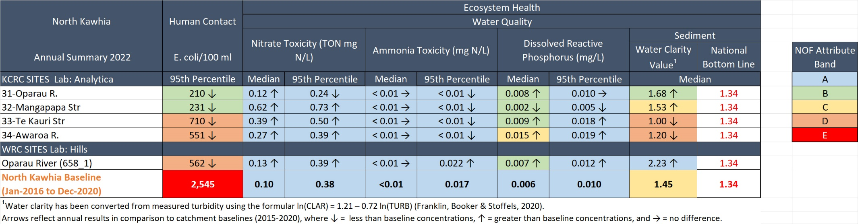

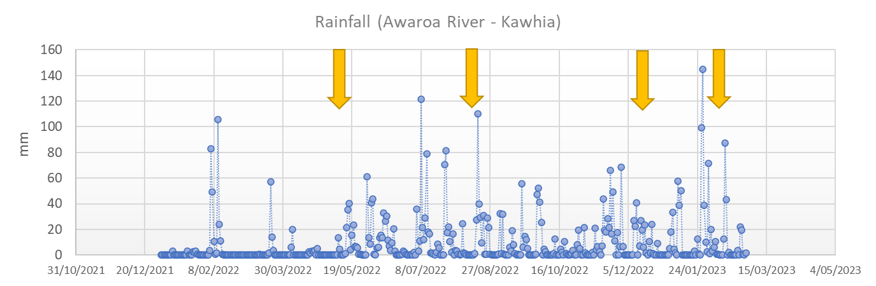
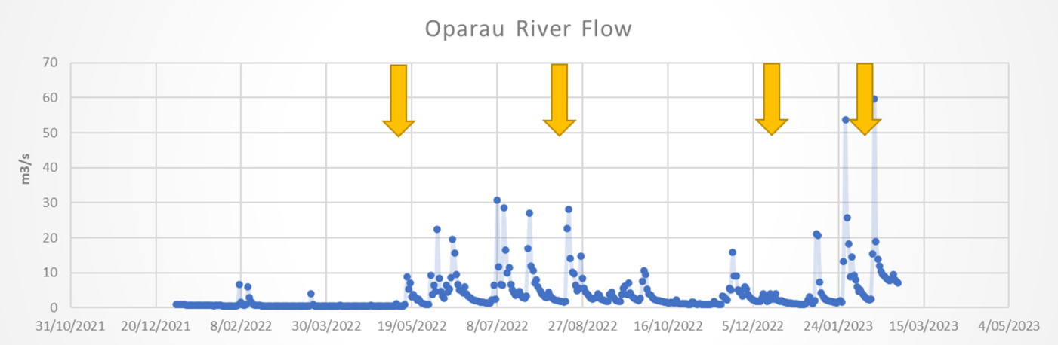
Yellow arrows in the rainfall and river flow graphs show the dates when quarterly water samples were collected.

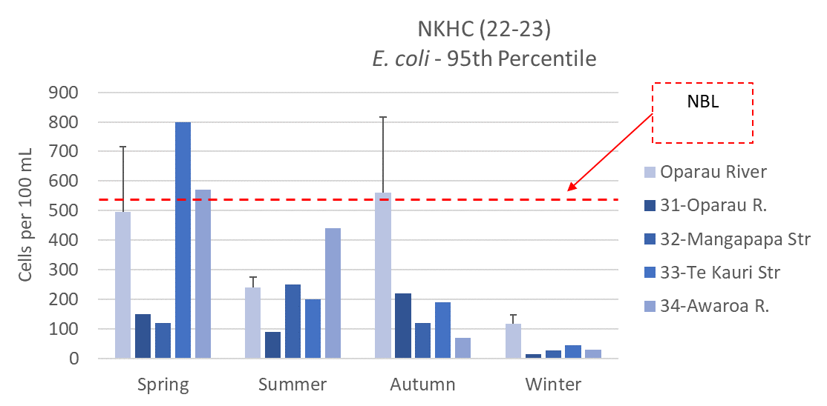
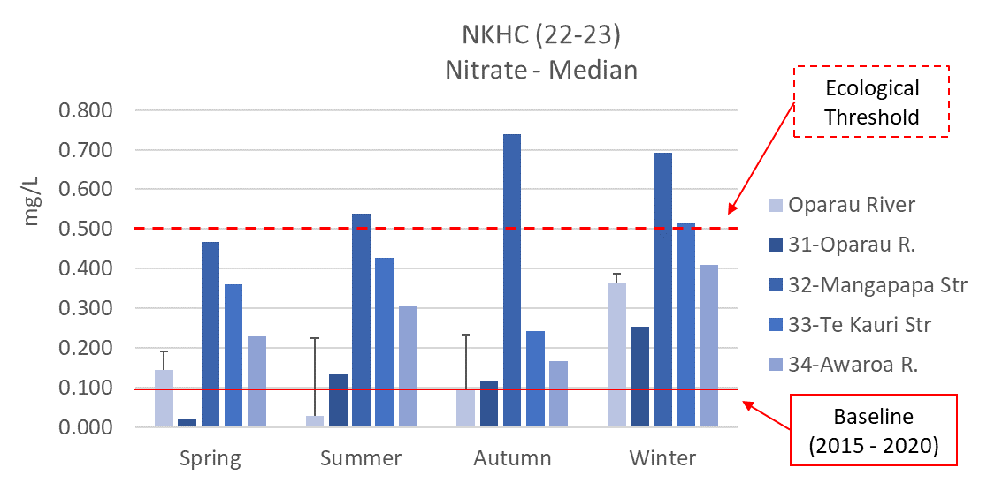
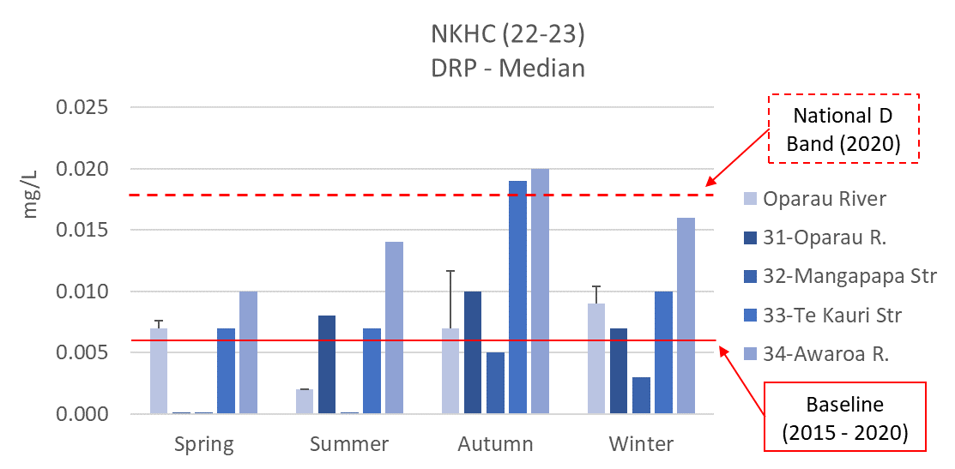
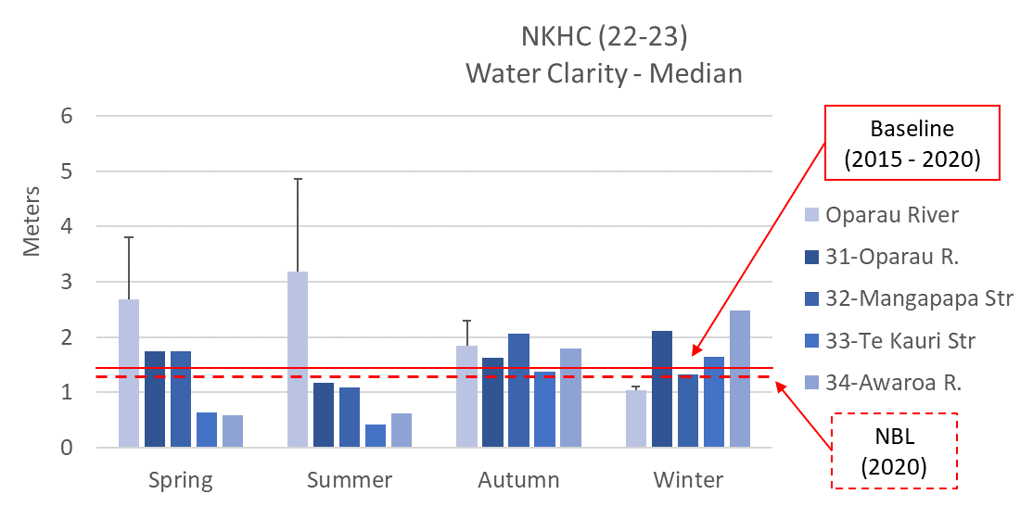
South Kawhia Harbour Care
Water quality was generally good. E. coli and dissolved reactive phosphorus (DRP) are the main contaminants to be aware of. E. coli was higher in spring and autumn and lower in winter. DRP was higher in autumn and lower in spring.
- E. coli concentrations were lowest at 37-Oteke Stream (249, 95th percentile values). E. coli was elevated at all other sites with the highest concentrations at 38-Mangatangi Stream (1,012). All sites were below the sub-catchment (SC) baseline (5yr baseline = 2,545). Overall concentrations were higher in spring and autumn and lower in winter.
- Nitrate concentrations were below toxicity levels at all sites. Concentrations were lowest at 36-Puaroa Stream and 37-Oteke Stream (median 0.28 mg/L; 95th percentile ≤ 0.46 mg/L) and highest at 38-Mangatangi Stream (median 0.41 mg/L; 95th percentile 0.76 mg/L). All sites had median annual nitrate concentrations above SC baselines (5yr baseline = median 0.10 mg/L; 95th percentile ≤ 0.38 mg/L). Overall concentrations were higher in winter and lower in spring.
- Ammonia concentrations were exceptionally low at all sites (median < 0.01 mg/L; 95th percentile ≤ 0.001 mg/L).
- Dissolved reactive phosphorus (DRP) concentrations were low at 35-Nghuinga stream and 27-Oteke stream (median ≤ 0.008 mg/L; 95th percentile ≤ 0.012 mg/L). While 36-Puaroa Stream had a low median concentration (0.009 mg/L) but also had a very high reading on 11th May 2022 (0.133 mg/L), consequently the 95th percentile value for this site was high (0.114 mg/L). Concentrations were slightly elevated at 38-Mangatangi Stream (median 0.011 mg/L; 95th percentile ≤ 0.012 mg/L). Only one site (37-Oteke Stream) had median concentrations equal to the SC baseline, all other sites were above the baseline (5yr SC baseline = median 0.006 mg/L; 95th percentile ≤ 0.010 mg/L). Overall concentrations were higher in autumn and lower in spring.
- Water clarity was good at all sites (between 0.84 m and 2.35 m), relative to the national bottom line (0.61 m). The highest water clarity was recorded at 37-Oteke Stream (2.35 m) and the lowest was recorded at 35-Nghuinga Stream (0.84 m). Overall water clarity was lower in summer (2023) and higher in spring (2022). Water clarity is reduced by suspended sediment during periods of higher rainfall and flow and may be reduced by algae growth during warmer months and periods of low flow.

