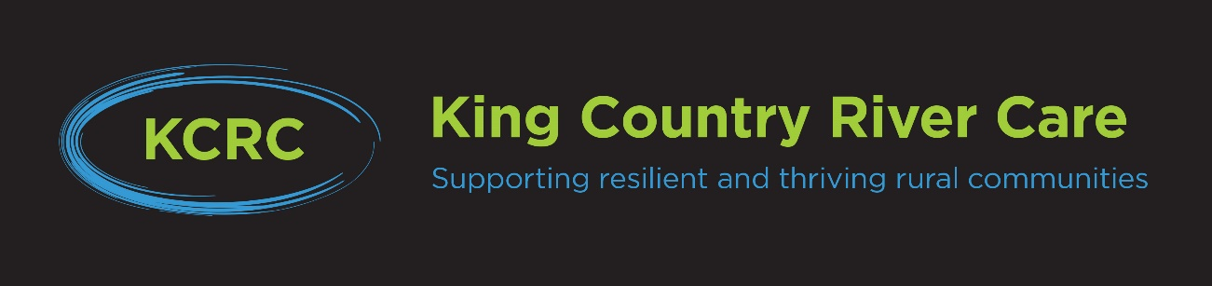
KCRC 1BT KICK START FUNDING UPDATE
August 2022
This funding is available to landowners in the Awakino, Mokau, Upper Mangaokewa, Marokopa, and Kawhia Harbour catchments for the 2023 planting seasons to cover riparian/restoration/erosion control projects identified in their Farm Environment Plan.
Funding is available to cover the costs of planting and fencing.

Applications are ideally received by mid-September 2022 for the 2023 planting season. The final date for accepting applications is mid-May 2023, assuming funding is still available. All work must be completed prior to 30 September 2023.

Please note KCRC may need to reduce the maximum amount of funding paid (scale back) for those landowners receiving their second round of funding in 2023.

Landowners need to complete a certain amount of planting to access funding; funding is capped relative to the total hectares of their farm included in their Farm Plan. Landowners choose the site(s), the type of plants and the type of fence they believe are appropriate for the project. They are responsible for purchasing and planting the plants, and for completing the fencing.

In order to access 1BT Kick Start funding landowners/farming businesses must:
- Have a relevant, recent (that is, written or reviewed within last the 12months), Farm Environment Plan including the following or similar:
i. a detailed resource inventory of your farm - infrastructure, features, and Land
Management Units LMUs (map)
ii. the strengths and weaknesses of these resources
iii. how you manage your resources to best suit your farming and environmental goals
iv. an action plan or works program that will enhance your properties soils, waterways, biodiversity, and climate change preparedness, and
v. a record of work/actions/monitoring undertaken
Your Farm Plan needs to be reflective of your sub-catchment priorities/needs.
You need to have your Farm Plan started but it does not need to be completed.
- Be willing to share progress, information, and feedback with other participants in your local sub- catchment group (SCG) and possibly host a SCG visit.
c) If selected for audit be willing to have a farm visit or drone survey of treatment area (by
KCRC or MPI).
d) Have attended at least two KCRC/Coast catchment events.
e) Farm within the Awakino, Mokau, Upper Mangaokewa, Marokopa and Kawhia Harbour catchments.
f) Not have received other funding for the submitted project.
g) Plant a specified minimum number of plants/trees (or poles); this is 1 plant/tree/pole per
$9.70 received from KCRC/1BT (for fencing & planting projects) or 1 plant/tree/pole per
$5.50 received from KCRC/1BT (for planting only projects).
h) Provide in kind contribution to the value of at least 25% above the agreed funding cap.
i) Sign a written agreement agreeing to the points above.

The KCRC 1BT Kick Start Application form provides more detail around what is required to receive this funding.
If you have any queries, please contact:
Anna Nelson (KCRC Coordinator)
Mobile: 0274 900501
Email: kcrivercare@gmail.com
Landline: 078777744.

